**Design an automatic night lighting system (with 4 connected led’s) such the system is only activated when the master control switch is pressed. a) Below 50% value of full brightness all LED’s constantly ON. b) Above 50% value of full brightness only first LED is ON.**

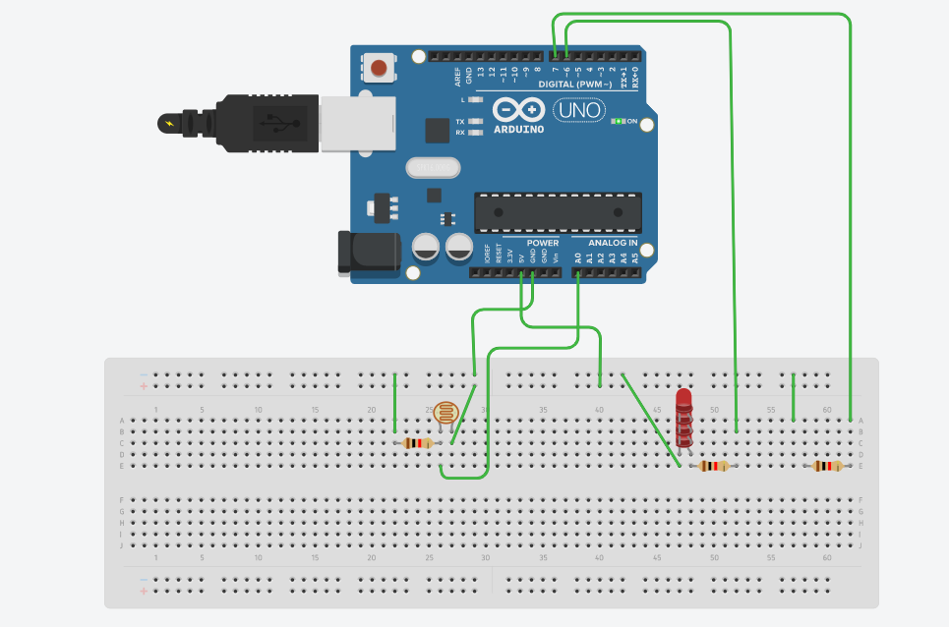

**Automatic night light control system** needs no manual operation for switching ON and OFF when there is need of light. It detects itself whether there is need for light or not. When darkness rises to a certain value then automatically light is switched ON and when there is other source of light i.e. day time, the light gets OFF.

In the project we use light detecting resistor as a light [sensor](https://www.engineersgarage.com/articles/sensors) & a NAND gate for detection of high level or low level of voltage to energize the [RELAY](https://www.engineersgarage.com/electronic-components/relays) coil which is used to interface the control circuit with the external light source.

Wastage of power is not desirable in any system. So it is very much economic to have this arrangement so that power is not wasted during day time where manual operation is not possible. Though we can use it in our daily life also for the betterment of our system.

While dealing with this project we faced a problem that the light remained on or off depending upon the presence of any other light source. If we want to make the light off in night hours when there is no need of light, or after switching off the light if we want to make the light on again it was not possible with the circuit investigated earlier. As we don’t want any manual operation we have an arrangement of doing this by means of sound (like clapping sound).This mechanism makes the circuit is more flexible.

By means of this circuit we can control any other electrical appliances as we use the double pole double throw relay switch.

Again for economic operation it is very much helpful and it is very much easy and cheap to make the circuit for house hold purposes.  
The operation and operating characteristics of the components which are used in the circuits are briefly outlined below-

**Using LDR** 

A single NAND gate, a PNP transistor and few other passive components are the only things needed to construct this useful gadget. The circuit description can be understood from the following explanation:

As shown in the diagram a single NAND gate N1 from the IC 4093 is configured as an inverter and a voltage monitor.

* A reference voltage can be set at its input with the help of VR1. This adjustment will set the level of darkness at which the system will change state.
* A LDR (Light Dependant Resistor) which is also connected at the input of N1 is used to sense a difference in light levels. A [LDR](https://www.engineersgarage.com/electronic-components/ldr-light-dependant-resistor) is in fact a resistor which changes its value with a change in the intensity of light falling on it.
* In the absence of light or when its dark, the LDR offers an infinite resistance and thus the input of N1 is kept at logic high due to the voltage received through VR1. This means that at this instant the output of N1 is logic low, the relay is activated through T1 and the lights (load) connected to the relay contacts are switched ON.
* With an increase in the ambient light the resistance of the LDR will gradually fall and after a certain level the input of N1 will become logic low. Immediately its output will go high switching OFF the transistor, the relay and the lights.
* [Capacitor](https://www.engineersgarage.com/tutorials/capacitors-introduction-types-applications) C1 has been kept to avoid the relay from chattering during twilight threshold levels.

Program

const int lamp = 7;

void setup() {

Serial.begin(9600);

pinMode(lamp, OUTPUT);

pinMode(6,OUTPUT);

}

void loop() {

int c = analogRead(A0);

delay(500);

if ( c<300){

digitalWrite(lamp,HIGH);

delay(1000);

digitalWrite(6,HIGH);

delay(1000);

}

else {

digitalWrite(lamp,HIGH);

delay(1000);

digitalWrite(6,LOW);

delay(1000);

}

}